**Homework:**

Explain how colors are defined in Y'CrCb color model.

What is the meaning of following chrominance sub- sampling patterns: a) 4:4:4, b) 4:2:2, and c) 4:2:0.

Answer:

The purpose of making this color model is in TV transition R, G and B are correlated, so when we want to transmit them we use more bandwidth because of repetitive data.so this model the uncorrelated form of RGB model, Cb and Cr needs lower bandwidth.

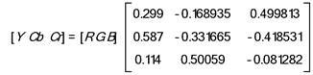The transform used takes an RGB input value with each component in the range [0-255] and transforms it into Y, Cb, and Cr, in the ranges [0.0, 255.0], [-128.0, 127.0], and [-128.0, 127.0], respectively. The Y-component is level-shifted down by 128, so that it also falls into the [-128.0, 127.0] range. The input tile in this level-shifted symmetric YCbCr color space is used as the input for the next stage of DWT. The matrix equation for this conversion is shown in the following figure.

Chrominance subsampling:

1. 4:4:4

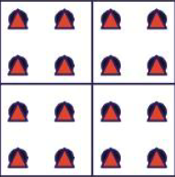This means that for every 4 pixels there are 4 Cb and 4 Cr pixel.

In fact there isn’t any subsampling.

1. 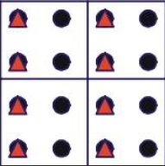4:2:2

Here for every 4 pixels 2 Cb and 2 Cr pixels.

In this picture subsampling just in horizontal axis has been done.

And sampled format is half of original one.

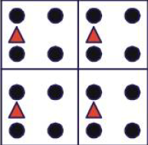

1. 4:2:0

In this format for every 4 pixels there is just one Cb and one Cr.

Subsampling by 2:1 both horizontally and vertically.

Example:

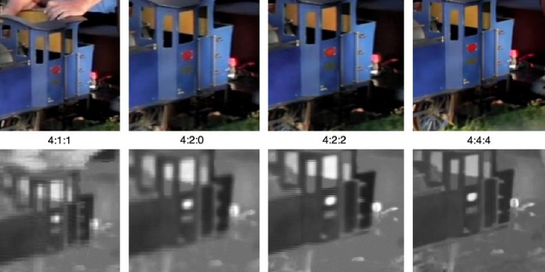This image shows the difference between four subsampling schemes. Note how similar the color images appear. The lower row shows the resolution of the color information

Calculate the number of bits per frame required to encode a Full HD (1920 × 1080 pixels per frame) video with these patterns.

Answer:

1. 4:4:4

Number of pixel: 1920*1080= 2073600 so we have 2073600 Cb and 2073600 Cr

Number of bits=2073600*24=49766400

1. 4:2:2

Number of pixel: 1920*1080= 2073600 so we have 2073600/2=1036800 Cb and 2073600/2 Cr

Number of bits=2073600*16=33177600

1. 4:2:0

Number of pixel: 1920*1080= 2073600 so we have 2073600/4=518400 Cb and 2073600/4 Cr

Number of bits=2073600*12=24883200